GuideStar
How to Claim Your GuideStar Profile

Go to guidestar.org and sign in or create an account
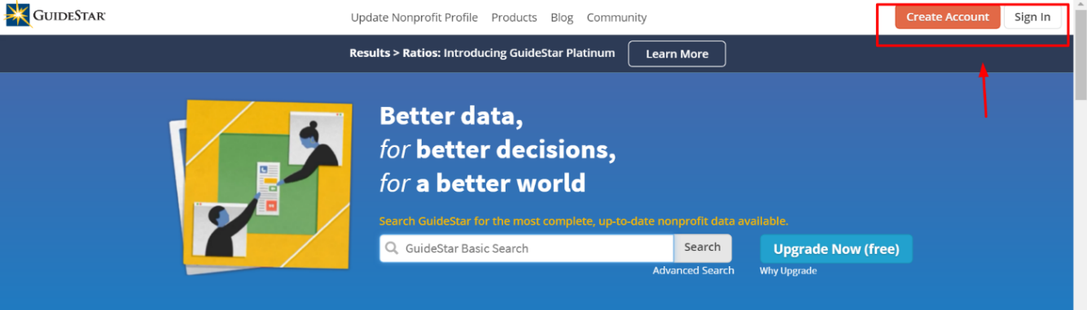

Click on the “Update Nonprofit Profile” link on the home page.


Click “Get started now” button


Enter your organization’s EIN number to request permission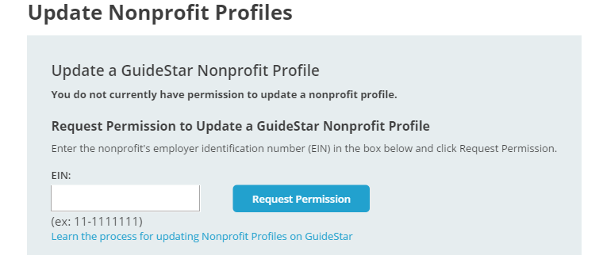

Complete the short application and receive access to your profile in up to 2 business days.

Sign in to Your Profile to Edit
Go to guidestar.org and sign in or create an account
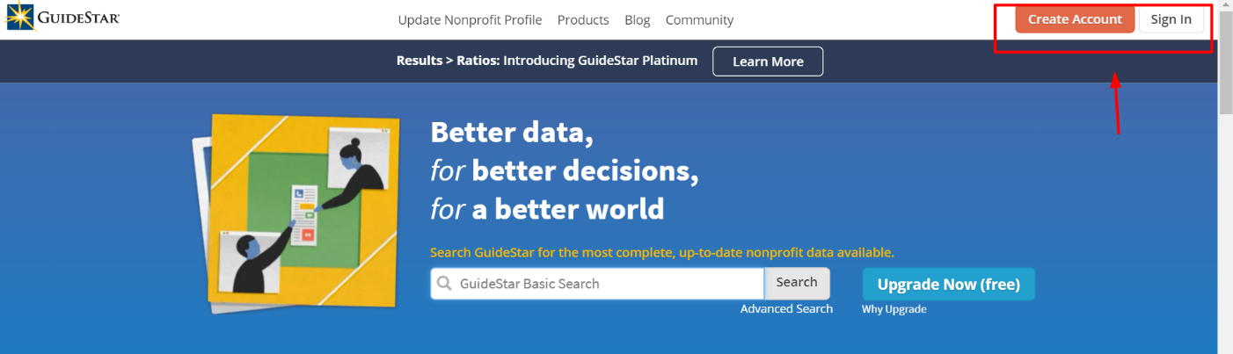

Click on the “Update Nonprofit Profile” link on the home page.

When you are signed in, you should see your organization listed on the page. Click on your organization's name or "edit form”. You will be taken the form to update your organization's profile.
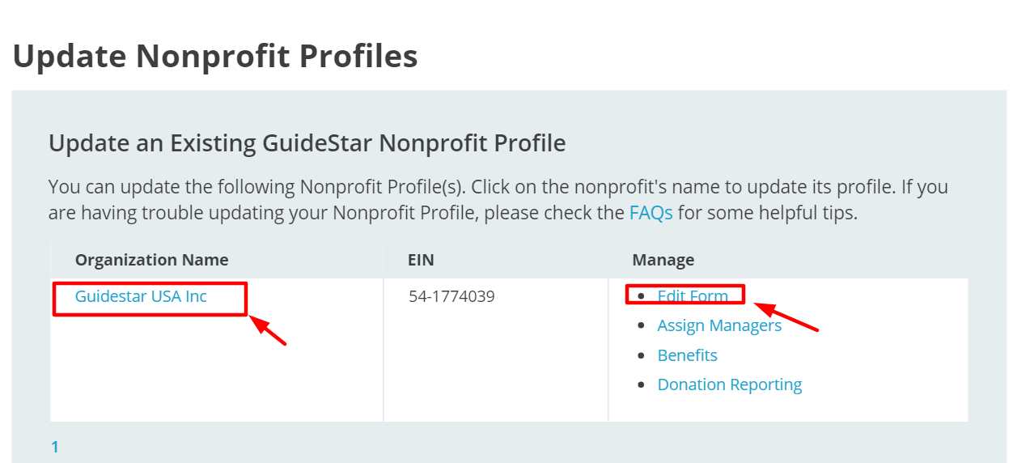

Board of Directors List
Once you are in the profile, you will see a task bar located to the left side of the page.
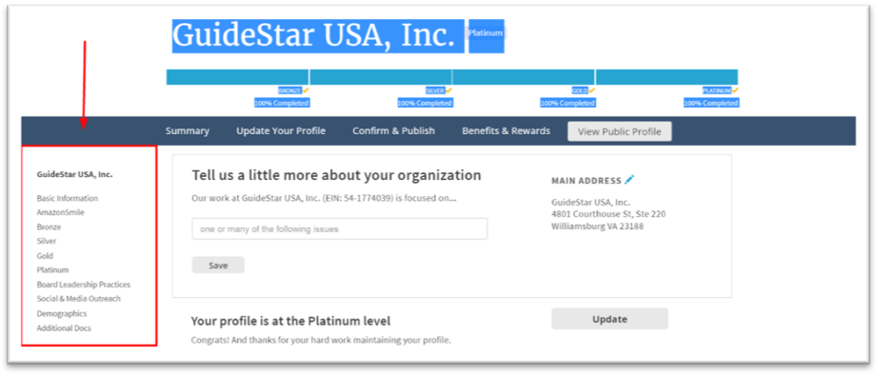

To provide the Board of Directors list click on the “Bronze” header to expand the selection list. Then click Board Members to enter. Type in each board member and click “save”

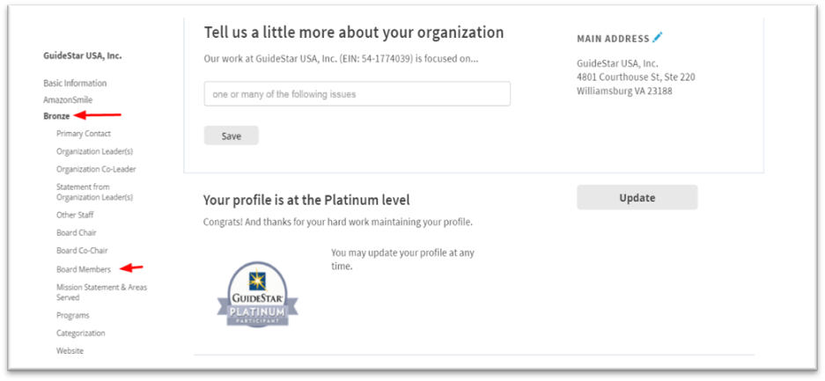

IRS Letter of Determination
To upload your IRS letter of determination click on the “Basic Information” link to expand the section. Then click “Letter of Determination”
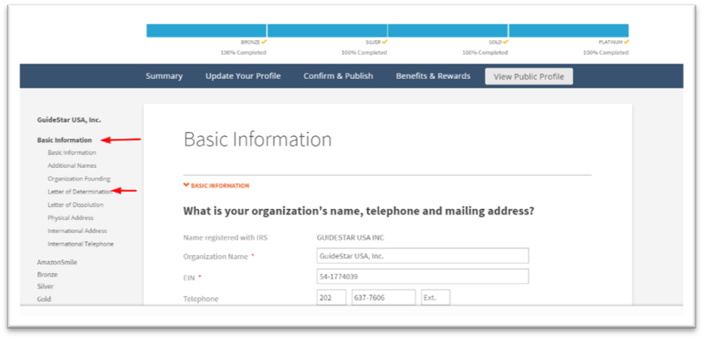

Click the “Add Letter of Determination” button.
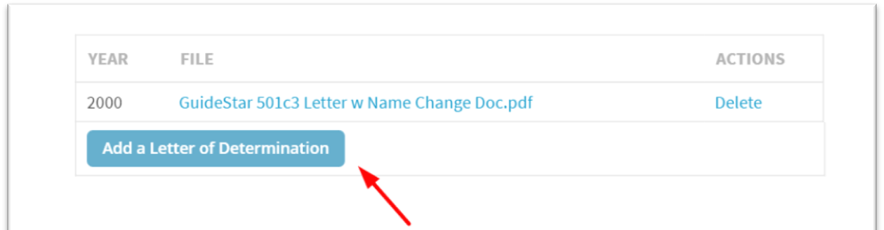

Follow the upload instructions on the pop-up screen 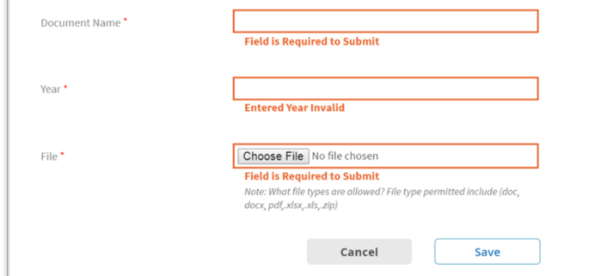
“Save”

IRS Form 990
To upload your IRS Form 990 click on the “Additional Docs” link to expand the section. Then click “IRS Documents”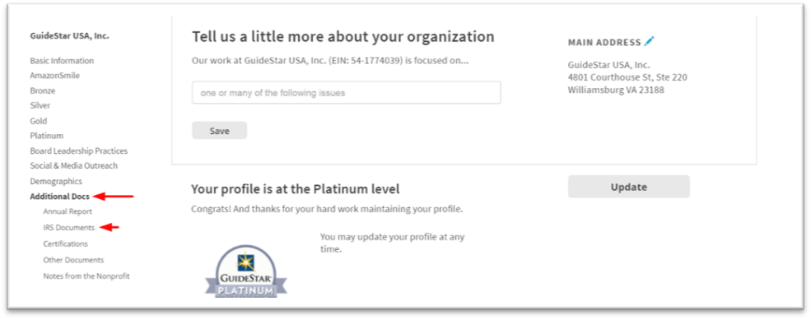

Click the “Add a Form“ button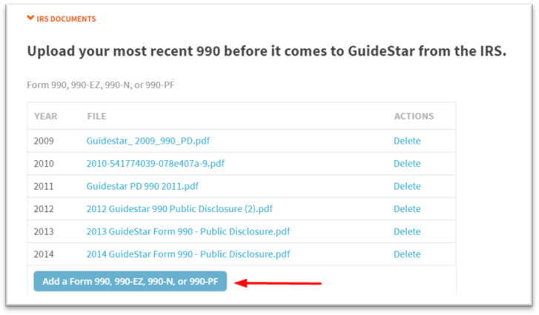
Follow the upload instructions on the pop-up screen and click “Save”
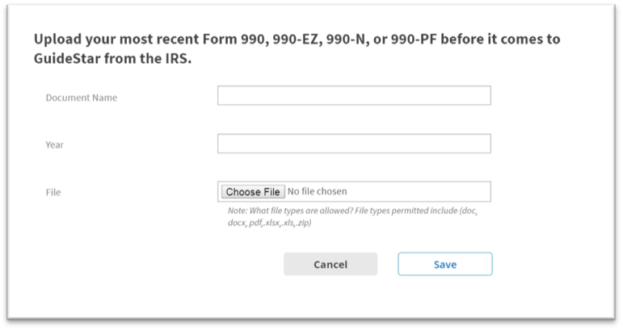

Annual Operating Budget
To enter your annual operating budget click on the “Silver” link to expand the section. Then click “Revenue”
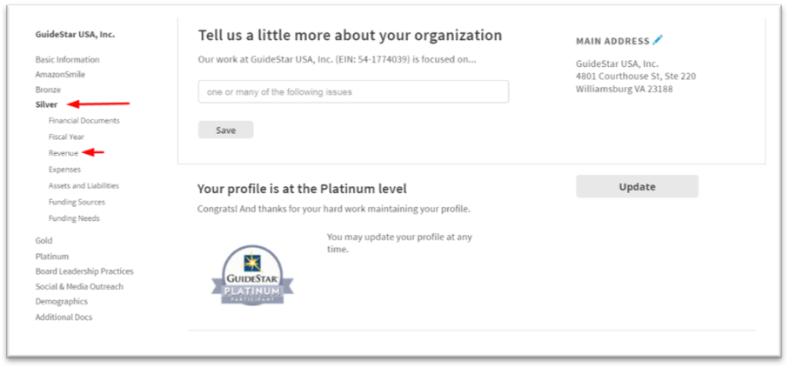
Enter relevant information for all applicable fields
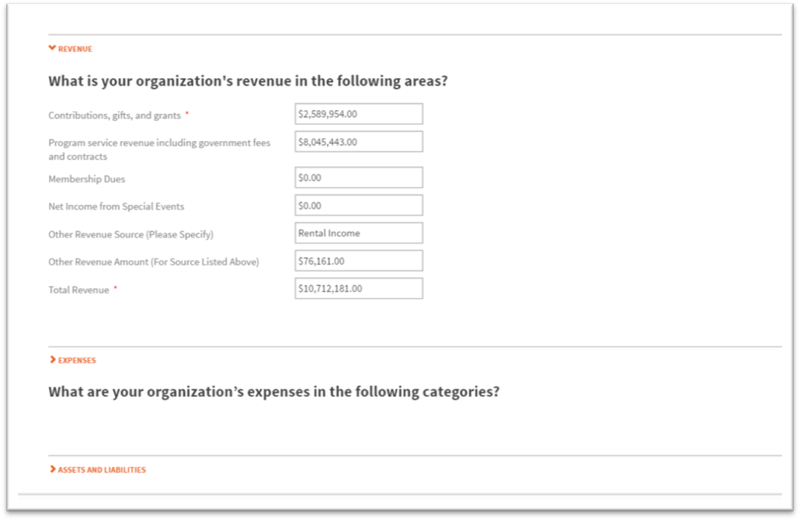

Demographic Information
To enter your demographic information click on the “Demographics” link to expand the section. Then click any section to get started
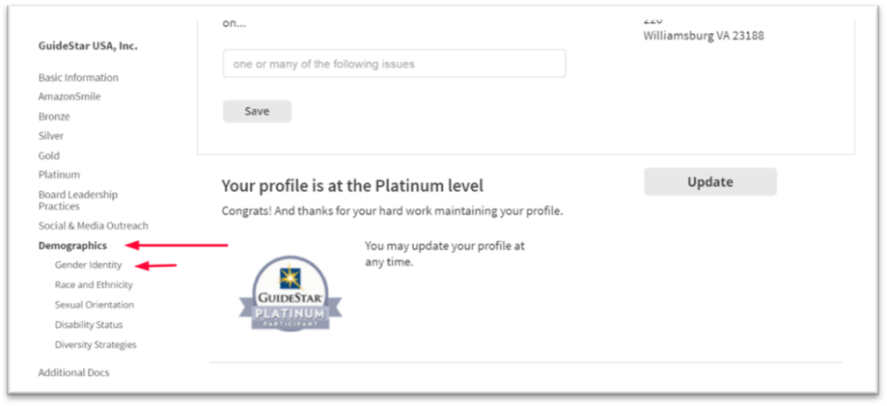

Enter relevant information for all applicable fields
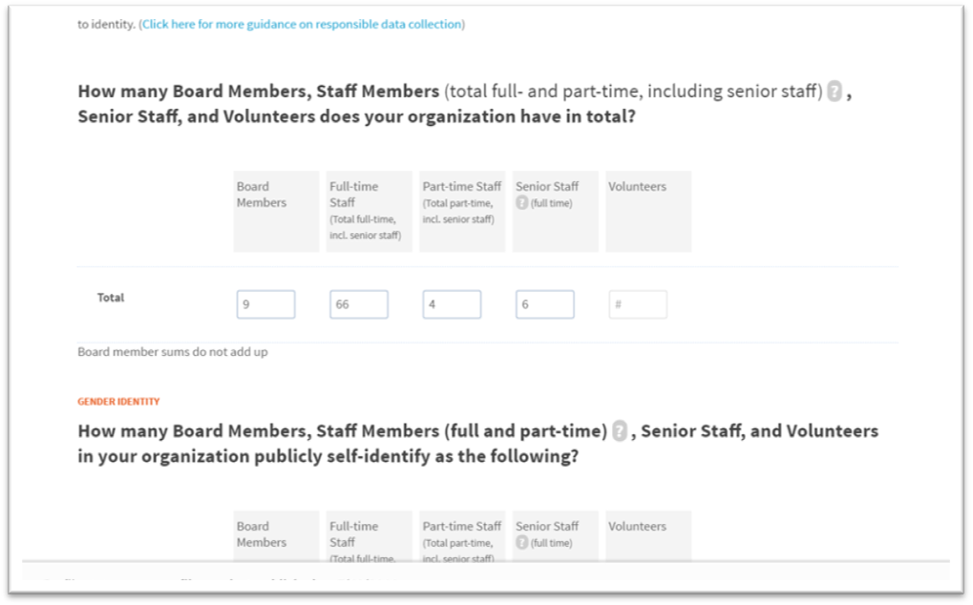

Publish on your GuideStar Profile
To publish changes made to your GuideStar Profile click the “Confirm & Publish” link at the top of the page
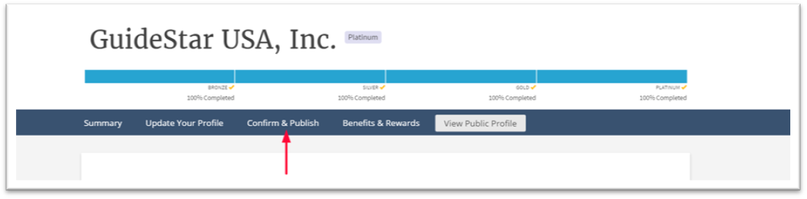

Check all relevant certification boxes and click the “Finish & Publish” button at the bottom of the screen
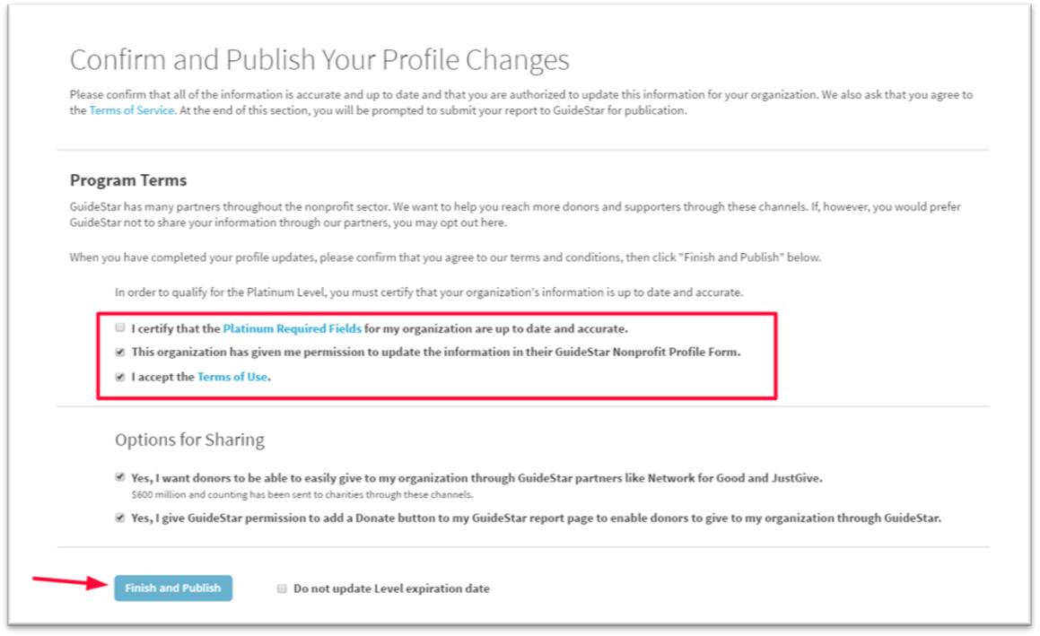

Support
To get more information on GuideStar for Education, visit the GuideStar Support Center or email edu@guidestar.org.

